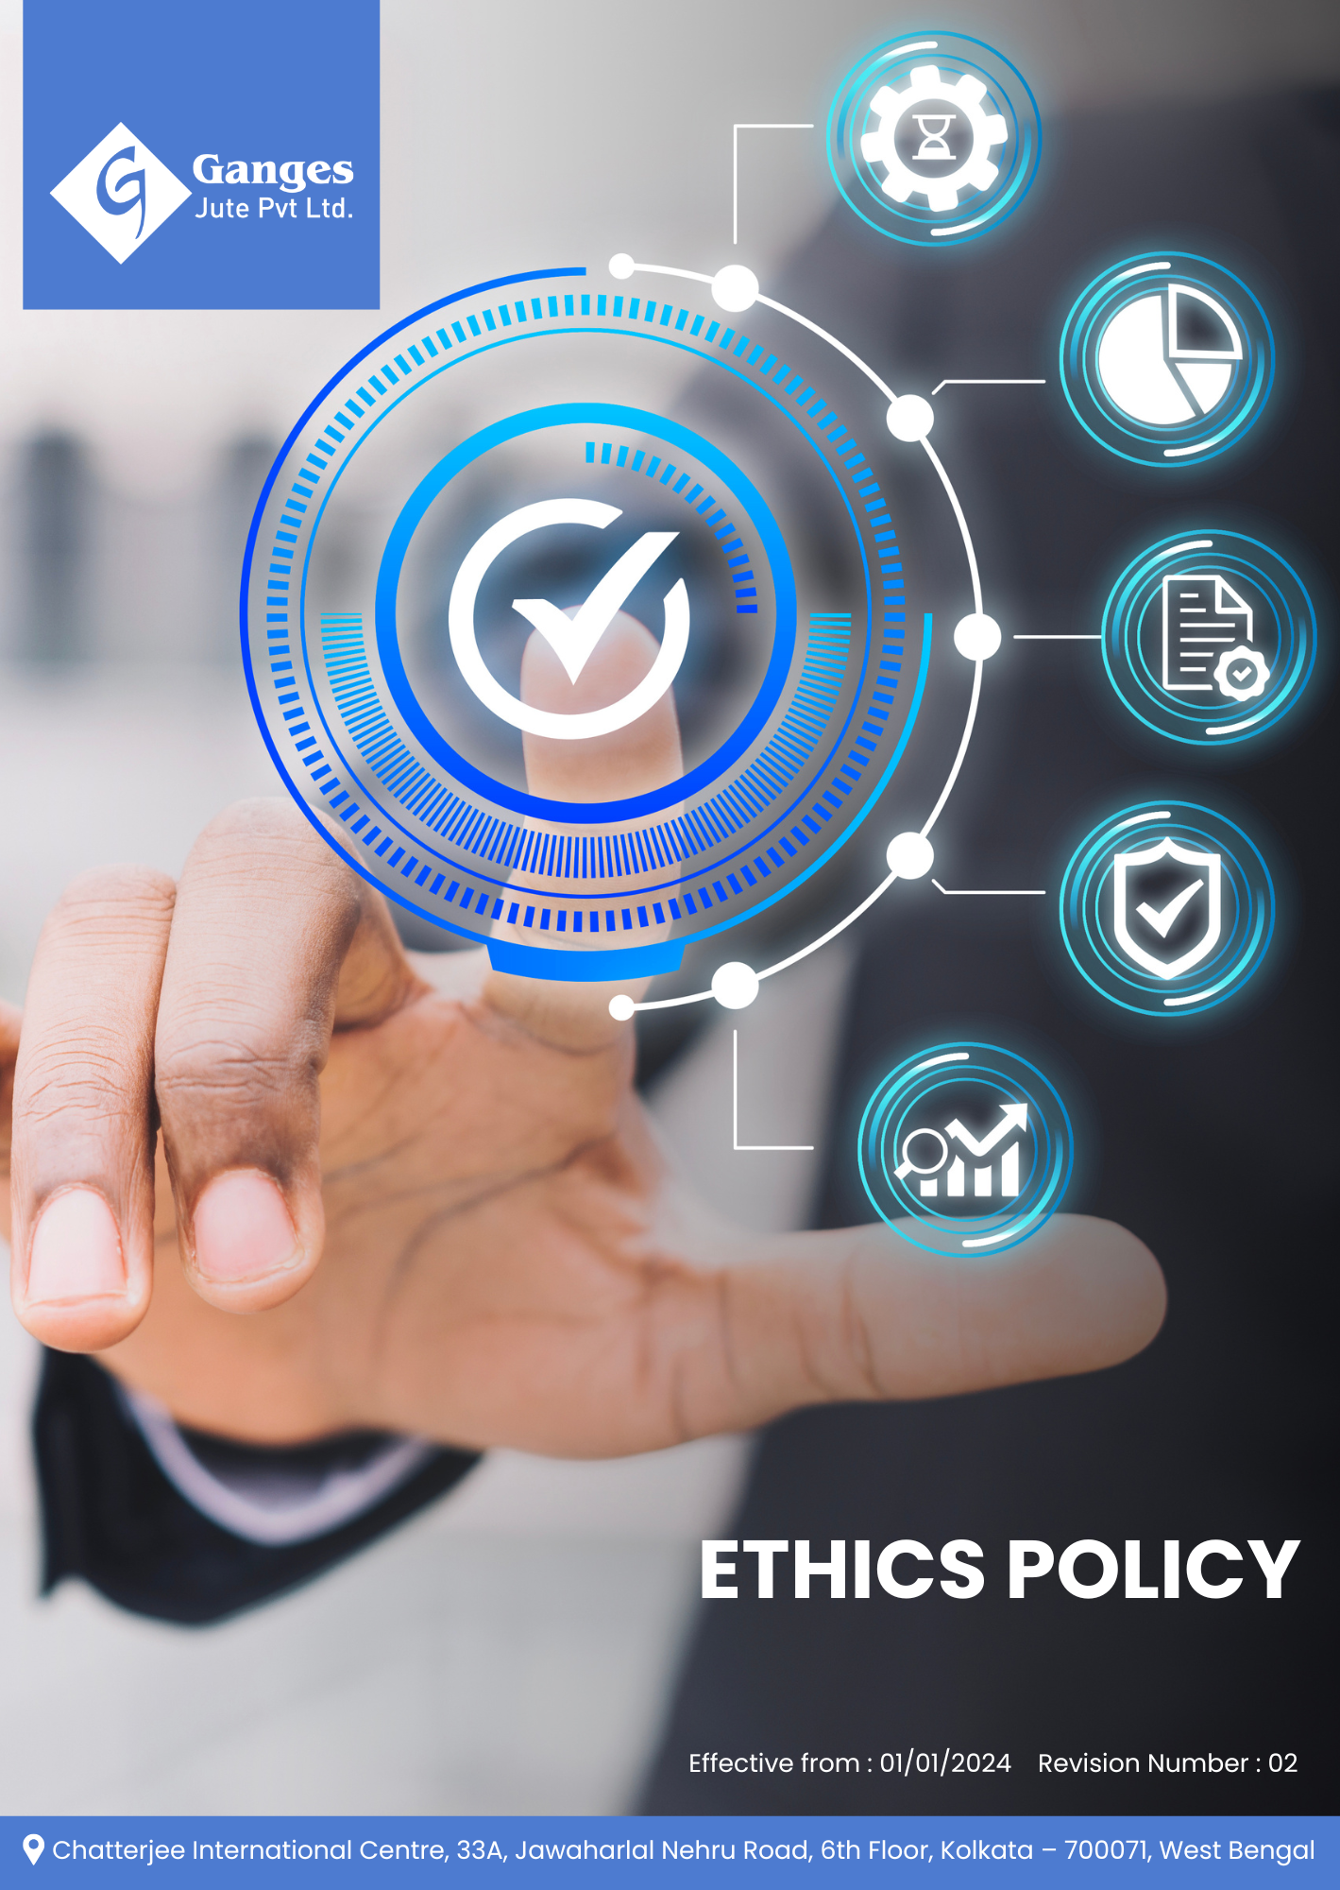

Table Of Contents

1. Why It Matters 3
2. The Ganges Jute Way 3
3. Scope 3
4. What's Expected 3
5. Jute's Journey to Ethical Excellence: A Ganges Jute Commitment 5
6. Governance and Allocation of Responsibilities 7
7. Acceptable and Unacceptable Ethical Conduct Across Key Risk Areas 9
8. Actions in Case of Policy Violations 11
9. Reporting Section 12
10. Covered SDGs 13
11. Review Mechanism 13
12. Employee Acknowledgement Form: Ethics Policy 15

Why It Matters
At Ganges Jute Pvt Ltd, we believe that ethical business practices are fundamental to our long-term success and sustainability. Our commitment to ethics goes beyond mere compliance; it is the cornerstone of our corporate culture and a key driver of our business strategy. By maintaining the highest standards of integrity, we build trust with our stakeholders, enhance our reputation, mitigate risks, and create a positive impact on society.

The Ganges Jute Way
Ganges Jute Pvt Ltd is committed to conducting business with unwavering ethical standards. We design, manufacture, and deliver our jute products while adhering to the principles of integrity, transparency, and accountability. Our ethical approach encompasses fair business practices, respect for human rights, environmental stewardship, and responsible corporate governance.

We set annual ethical goals, develop necessary capabilities, and commit appropriate resources to achieve this policy through innovation, operational excellence, and aligning Ganges Jute's entire value chain with our ethical standards.

Scope
This policy applies to all employees, stakeholders, contractors, partners, customers, contractual workers, and anyone acting on behalf of following sites:

 | Ganges Jute Pvt Ltd
 | Address: Bansberia, Hooghly District, West Bengal, India
 | https://gangesjute.com/

What's Expected
- Ethical Compliance
Ganges Jute Pvt Ltd is committed to conducting business with the highest ethical standards. We go beyond legal compliance and boldly integrate ethical considerations into all aspects of our operations, including fostering a culture of employee engagement and community support. By setting clear ethical performance standards and utilizing a comprehensive Ethical Management System, we drive continuous ethical compliance and improvement in areas such as Corruption, Fair Competition, and Data Protection and Cybersecurity, including through:
- Prohibiting all forms of bribery, kickbacks, and improper payments, ensuring robust due diligence procedures, regular anti-corruption training, and transparent financial record-keeping;
- Establishing clear procedures for reporting ethical concerns, protecting whistleblowers from retaliation, ensuring fair investigations, and implementing an ethics hotline for anonymous reporting;
- Maintaining accurate financial records, implementing strong internal controls, conducting regular internal audits, and ensuring compliance with financial regulations;
- Managing conflicts of interest responsibly by requiring employees to disclose any actual or potential conflicts, avoiding situations where personal interests may influence business decisions, and ensuring that all conflicts are addressed transparently in line with company procedures.
- Implementing robust systems to detect and prevent money laundering, conducting thorough background checks on business partners, adhering to sanctions, and providing training on recognizing suspicious activities;
- Competing fairly and ethically, prohibiting anti-competitive practices, providing clear guidelines on interactions with competitors, and ensuring compliance with antitrust laws;
- Implementing strict data quality control measures, conducting regular audits, establishing clear policies on data management, and training employees on the importance of data integrity;
- Respecting intellectual property rights, protecting our innovations through legal measures, providing guidelines on handling proprietary information, and fostering a culture of innovation;
- Implementing robust cybersecurity measures, ensuring compliance with data protection regulations, providing regular training on data privacy, and conducting periodic security audits;
- Maintaining a diverse and independent Board of Directors, ensuring clear separation of duties between the Board and management, providing transparent communication to stakeholders, and maintaining effective internal control systems

Jute's Journey to Ethical Excellence: A Ganges Jute Commitment
- Establishes 2022 as the Baseline year for measuring progress and achievements in our sustainability initiatives.

- Integrity in Business Practices and Anti-Corruption Measures:
- We aim to achieve a 100% completion rate for annual anti-corruption training for all employees by 2030, implementing an advanced e-learning platform with real-world scenario simulations.
- We plan to implement an AI-powered transaction monitoring system by 2030, capable of detecting 95% of potential corrupt practices in real-time.
- We intend to obtain ISO 37001 Anti-Bribery Management System certification for all our operations by 2030, demonstrating our commitment to international best practices.

- Ethical Dispute Resolution and Whistleblower Protection:
- We aim to establish an independent Ethics Committee by 2030, comprising both internal and external experts, to oversee dispute resolution and ethical concerns.
- We plan to implement a secure, anonymous whistleblowing platform by 2030, with a target of addressing 100% of valid reports within 14 days.
- We intend to achieve a 95% resolution rate for reported ethical issues within 30 days by 2030, supported by a dedicated team of ethical investigators.

- Financial Transparency and Fraud Prevention:
- We aim to implement a real-time financial monitoring and anomaly detection system by 2030, capable of identifying 99% of potentially fraudulent activities.
- We plan to achieve zero material weaknesses in internal controls by 2030, through continuous process improvement and regular third-party audits.
- We intend to obtain ISO 27001 certification for information security management by 2030, ensuring the highest standards of data protection for our financial systems.

- Conflict of Interest Identification and Management
- Provide conflict of interest awareness training to 100% of employees by 2030, covering identification of conflicts, disclosure requirements, and expected ethical behaviour.
- Conduct conflict of interest risk assessments covering 100% of key functions by 2030, including procurement, sales, finance, and management, to identify and address potential risk areas
- Ensure that 100% of identified conflicts of interest are reviewed and managed appropriately by 2030.

- Economic Misconduct Prevention:
- We aim to implement an advanced AML (Anti-Money Laundering) screening system for all transactions by 2030, covering 100% of our financial operations.
- We plan to achieve 100% compliance with FATF (Financial Action Task Force) recommendations by 2030, conducting bi-annual internal assessments.
- We intend to conduct comprehensive economic crime risk assessments annually, starting 2030, with a goal of mitigating 95% of identified high-risk areas within one year.

- Fair Market Practices and Competition Ethics:
- We aim to develop and implement a Competition Compliance Program by 2030, including tailored guidelines for each department.
- We plan to achieve a 100% completion rate for antitrust training for all relevant employees by 2030, with annual refresher courses.
- We intend to conduct annual antitrust audits starting 2030, with a target of zero competition law violations.

- Data Integrity and Information Management:
- We aim to implement a centralized data governance platform by 2030, ensuring 99.9% data accuracy across all systems.
- We plan to achieve ISO 8000 certification for data quality by 2030, demonstrating our commitment to maintaining the highest standards of data integrity.
- We intend to reduce data quality issues by 80% by 2030, compared to 2024 through AI-powered data cleansing tools and continuous staff training.

- Intellectual Property Rights and Innovation Protection:
- We aim to implement an IP management software system by 2030, cataloguing and protecting 100% of our intellectual assets.
- We plan to increase patent filings by 40% by 2030, fostering a culture of innovation while ensuring proper protection.
- We intend to achieve zero IP infringement incidents by 2030, through rigorous monitoring and swift legal action when necessary.

- Digital Security and Privacy Safeguards:
- We aim to implement a Zero Trust security architecture by 2030, covering 100% of our digital infrastructure.
- We plan to achieve ISO 27701 certification for privacy information management by 2030, ensuring best practices in data privacy.
- We intend to reduce successful phishing attempts by 90% by 2030, through advanced employee training and AI-powered email filtering.

- Ethical Supply Chain Management:
- We aim to achieve 100% supplier adherence to our Ethical Supplier Code by 2030, conducting annual audits and providing support for improvement.
- We plan to implement a blockchain-based supply chain traceability system by 2030, ensuring transparency from raw material to end product.
- We intend to conduct comprehensive ethical audits for all Tier 1 suppliers annually by 2030 with a goal of extending to Tier 2 suppliers by 2030.

Governance and Allocation of Responsibilities
The Ethics Policy at Ganges Jute Pvt Ltd sets forth a structured governance model to ensure adherence to the company's high ethical standards. The policy's governance and responsibilities are as follows:
- Board of Directors:
- Oversees the overall ethical strategy and approves long-term ethical goals.
- Ensures alignment of ethical initiatives with business objectives and stakeholder expectations.
- Reviews and approves the annual Ethics and Compliance Report.

- Chief Ethics Officer (CEO):
- Leads the development and implementation of the Ethics Policy across the organization.
- Reports directly to the Board of Directors, providing Annually updates on ethical performance.
- Chairs the Ethics Committee and oversees the ethics and compliance program.

- Senior Management:
- Provides leadership in implementing the Ethics Policy within their respective divisions.
- Allocates necessary resources and integrates ethical metrics into performance evaluations.
- Participates in regular ethics training and leads by example.

- Ethics Committee:
- Comprises representatives from various departments including Legal, HR, Finance, and Operations.
- Meets monthly to review ethical performance, investigate reported incidents, and recommend policy improvements.
- Oversees the implementation of ethical initiatives and training programs.

- Departmental Heads:
- Responsible for integrating ethical practices into their respective areas of operation.
- Ensure compliance with ethical standards and support ethical training efforts.
- Conduct regular ethical risk assessments within their departments.

- Compliance Officer:
- Ensures adherence to legal and regulatory requirements related to ethics and compliance.
- Conducts regular ethical risk assessments and implements mitigation strategies.
- Manages the ethics helpline and oversees the investigation of reported incidents.

- Human Resources Manager:
- Integrates ethics into recruitment, onboarding, and performance management processes.
- Coordinates ethics training programs for all employees.
- Manages the annual Ethical Climate Survey.

- Employees:
- Adhere to the Ethics Policy in all business activities.
- Report any ethical concerns through appropriate channels.
- Participate in mandatory ethics training programs annually.
- Contribute to fostering a culture of integrity within the organization.

Acceptable and Unacceptable Ethical Conduct Across Key Risk Areas
To guide ethical behaviour and prevent misconduct, Ganges Jute Pvt Ltd clearly defines what is considered acceptable and unacceptable conduct across key ethical risk areas. All employees, contractors, and representatives of the Company are expected to follow these guidelines in their daily activities.
Risk Area | Acceptable Conduct | Unacceptable Conduct
Anti-Corruption and Fraud Prevention | - Reporting any suspected bribery, fraud, or unethical conduct through approved reporting channels.  - Maintaining complete, accurate, and transparent business and financial records.  - Declining gifts, favours, or incentives that could influence business decisions. | - Offering, giving, soliciting, or accepting bribes or improper advantages.  - Falsifying or manipulating records.  - Ignoring or concealing potential corruption or fraud risks.
Conflict of Interest Management | - Disclosing any actual or potential conflicts of interest.  - Seeking approval before engaging in outside employment or business relationships.  - Following internal conflict-of-interest procedures. | - Making decisions that benefit personal interests over company interests.  - Engaging in conflicting business activities without approval.  - Misusing company assets for personal gain.
Prevention of Money Laundering and Financial Misconduct | - Reporting unusual or suspicious transactions.  - Performing due diligence on new business partners.  - Maintaining clear transaction records. | - Processing transactions without legitimate business purpose.  - Ignoring red flags related to financial misconduct.  - Structuring transactions to bypass controls or reporting requirements.
Fair Competition and Market Practices | - Competing fairly and transparently.  - Complying with competition and antitrust laws.  - Maintaining integrity in pricing and negotiations. | - Price-fixing, bid-rigging, or market-sharing.  - Sharing sensitive business information with competitors.  - Abusing market position to restrict fair competition.
Information Security and Data Protection | - Protecting confidential company and stakeholder information.  - Following internal IT and data protection guidelines.  - Reporting suspected data security incidents promptly. | - Sharing confidential data with unauthorised persons.  - Using unapproved systems for storing or transmitting data.  - Accessing or misusing information without business need.

Actions in Case of Policy Violations
- Investigation
- Objective: To ensure a thorough and impartial examination of reported ethical violations.
- Reporting: All reported incidents should be promptly logged in the ethics reporting system or helpline. Reports can be made anonymously if necessary.
- Initial Assessment: The Compliance Officer or Ethics Committee conducts a preliminary review to determine if the report warrants a formal investigation.
- Investigation Team: An investigation team, led by the Chief Ethics Officer and comprising members from relevant departments (Legal, HR, Finance, etc.), is formed to handle the case.
- Evidence Collection: The team collects all relevant evidence, including documents, emails, witness statements, and any other pertinent information.
- Interviews: Key individuals involved, including the complainant, accused, and witnesses, are interviewed to gather detailed accounts of the incident.
- Analysis: The investigation team analyzes the evidence and assesses whether the violation aligns with the specifics of the Ethics Policy.
- Report: A comprehensive investigation report is prepared, detailing findings, conclusions, and recommendations.
- Review and Decision: The report is reviewed by the Ethics Committee, which makes decisions regarding further actions based on the findings.

- Disciplinary Measures
- Objective: To address the violation appropriately and enforce accountability.
- Corrective Actions: Depending on the severity, corrective actions may include mandatory training, counselling, or changes in job responsibilities.
- Disciplinary Actions: For more severe violations, disciplinary actions could include written warnings, suspension, demotion, or other penalties as per company policy.
- Termination: In cases of severe or repeated violations, termination of employment may be considered. This decision should be made in accordance with legal and company procedures.
- Documentation: All disciplinary actions and decisions must be thoroughly documented, including the rationale for the action taken and any communication with the involved parties.
- Appeal Process: Employees subject to disciplinary actions have the right to appeal the decision through a formal process, ensuring fairness and transparency.

Reporting Section
- Internal Reporting:
- Annual Ethics Dashboard:
- The CEO presents a comprehensive ethics dashboard to the Board and senior management.
- The dashboard highlights key ethical performance indicators, incident trends, and progress on ethical initiatives.

- Ethics Incident Reporting:
- A dedicated ethics helpline is available 24/7 for employees to report ethical concerns.
- All reports are logged, investigated, and resolved within 30 days, with regular updates to the Ethics Committee.

- External Reporting:
- External reporting is conducted annually to communicate our Ethical performance to stakeholders, including customers, investors, and regulatory bodies.
- Reports are prepared in accordance with internationally recognized standards such as the Global Reporting Initiative (GRI) guidelines or UN Global Compact Communication on Progress.

- Stakeholder Engagement:
- We actively engage with stakeholders to gather feedback, address concerns, and foster transparency in our Ethical responsibility practices.
- Stakeholder input is considered in decision-making processes and incorporated into Ethical initiatives where applicable.

Covered SDGs
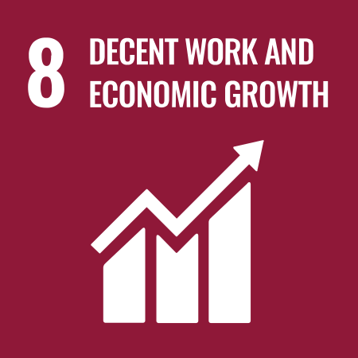 | 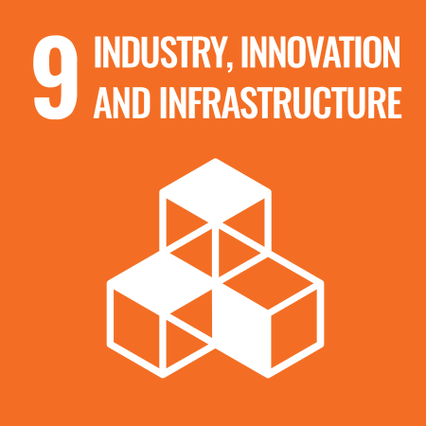 |  | 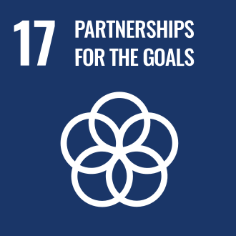

Review Mechanism
- Annual Performance Review:
- An annual performance review is conducted to assess progress towards Ethical Responsibility goals and targets.
- Key achievements, challenges, and areas for improvement are identified through a comprehensive evaluation process.

- Continuous Improvement:
- Feedback from performance reviews, internal audits, and stakeholder engagement activities is used to identify opportunities for continuous improvement.
- Adjustments to strategies, policies, and action plans are made as necessary to enhance social performance and address emerging issues.

- Policy Review and Update:
- The Chief Ethics Officer reviews this policy every two years to ensure alignment with changing regulatory requirements, industry best practices, and stakeholder expectations.
- Updates to the policy are communicated internally, and relevant training is provided to ensure awareness and compliance.

- Revision History

Revision No. | Revision Date | Description of Change
01 | 01-01-2023 | Initial release of the Ethics Policy
02 | 01-01-2025 | Modified sustainability targets with revised achievement timelines, added acceptable and unacceptable conduct guidelines, and introduced a formal Revision History table

(Signature)
Approved By: Mr. Ashwini Kariwala
Designation: Executive Director
Last Review Date: 01-01-2025 Next Review Date: 01-01-2027

Employee Acknowledgement Form: Ethics Policy

I, acknowledge that I have received, read, and understood Ganges Jute Pvt Ltd's Ethics Policy. I am aware of the company's commitment to conducting business with the highest ethical standards, including integrity, transparency, and accountability in all our operations.
I understand my role in upholding this policy, which includes adhering to ethical business practices, reporting any ethical concerns, and participating in required ethics training. I agree to comply with all aspects of the Ethics Policy in my daily work and to contribute to fostering a culture of integrity within the organization.
By signing below, I confirm my commitment to upholding Ganges Jute Pvt Ltd's Ethics Policy and supporting the company's ethical standards.

Employee Name:
Employee Signature:
Date:

